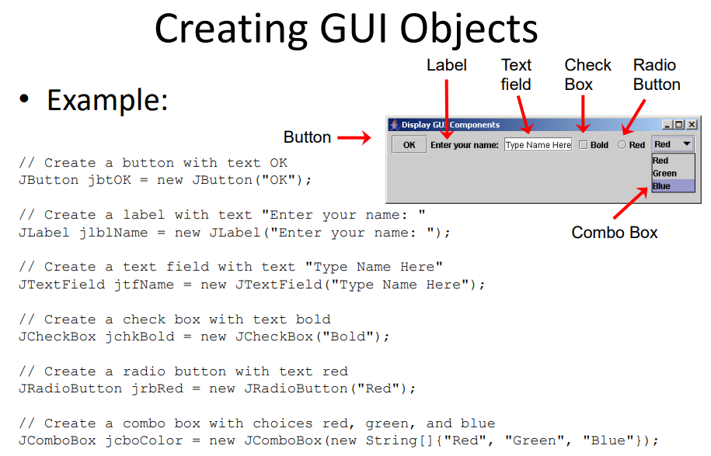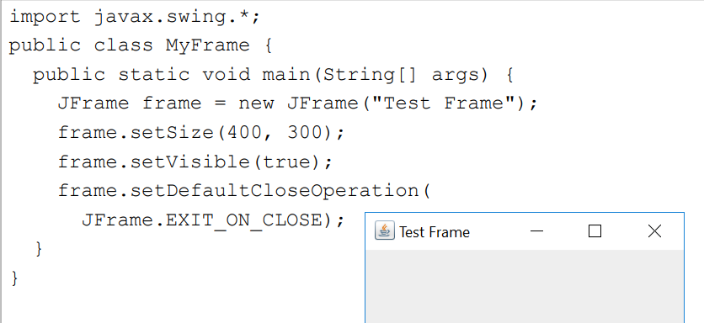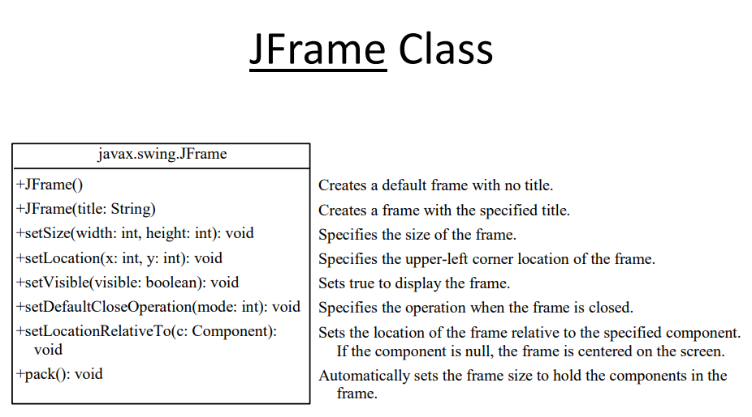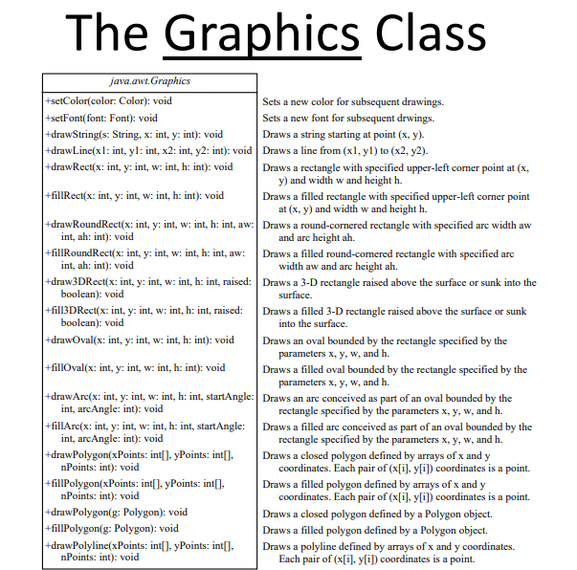
setLayout(new FlowLayout(FlowLayout.LEFT, 10, 20));
setLayout(new GridLayout(3, 2, 5, 5));//a 3 by 2 table occur(vertical = 3, horizontal=2)
setLayout(new BorderLayout(5, 10));//use BorderLayout.SOUTH to control
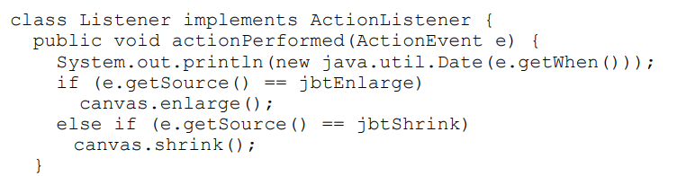
Jbutton when clicked
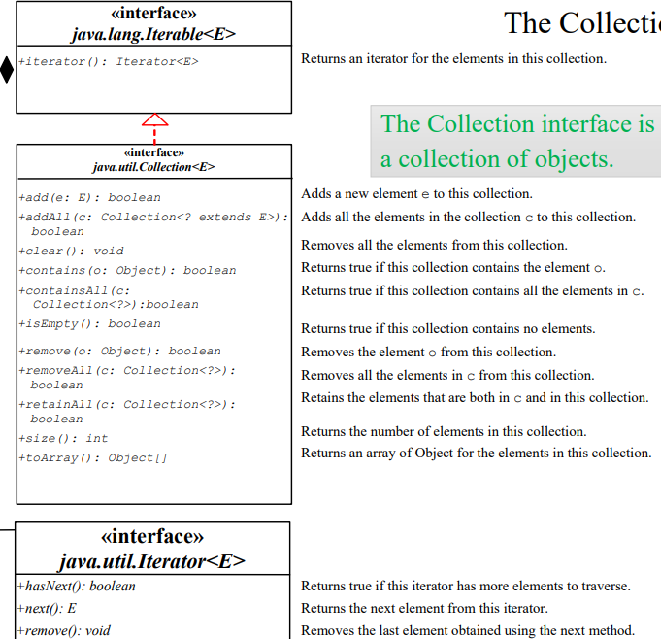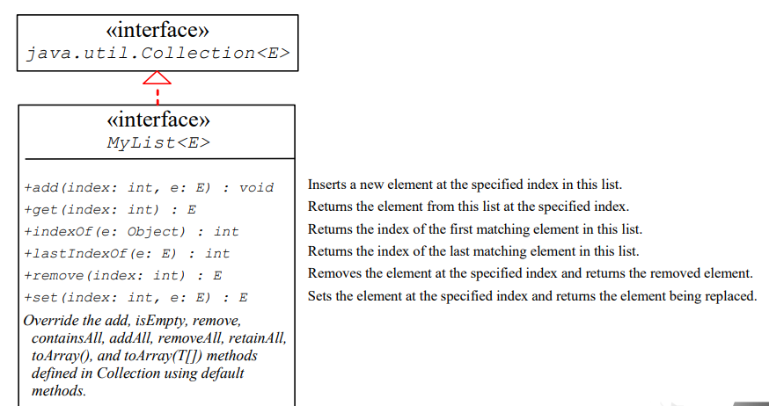

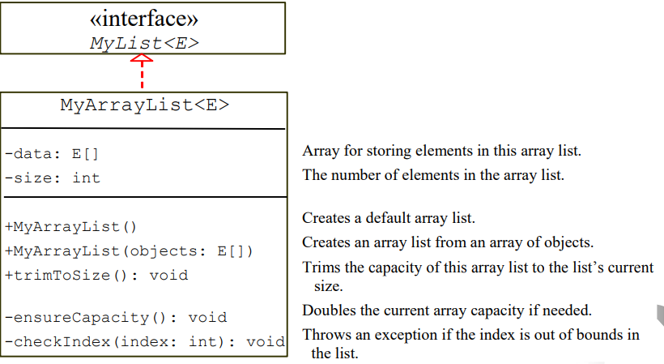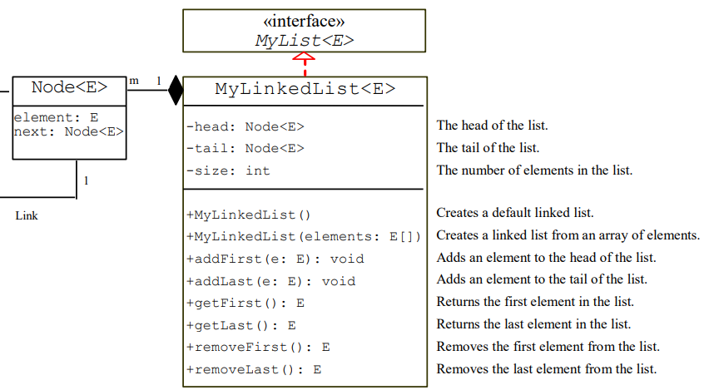
Poll() and pop()to add from head or tail
import java.util.ArrayList; and import java.util.LinkedList;
